Lab: Syntax, Functions and Statements

Problems for in-class lab for the ["JavaScript Advanced" course @ SoftUni](https://softuni.bg/trainings/3588/js-advanced-january-2022). Submit your solutions in the SoftUni judge system at <https://judge.softuni.bg/Contests/2749/Syntax-Functions-and-Statements-Lab>

# Echo Function

Write a JS function that takes **one string parameter** and **prints** on two lines the **length** of the parameter and then the **unchanged parameter** itself.

**Examples**

|  |  |
| --- | --- |
| **Input** | **Output** |
| **'Hello, JavaScript!'** | **18**  **Hello, JavaScript!** |
| **'strings are easy'** | **16**  **strings are easy** |

**Hints**

* + Write a function that receives a single **parameter**.
  + Use the console.log function to print text on the console. Each call prints a newline automatically.
  + The string’s **length property** is used to determine how many characters are in a given string

# String Length

Write a JS function that takes **three string arguments** as an input. Calculate the **sum** of the **length** of the **strings** and the **average length** of the strings **rounded down** to the nearest integer.

The **input** comes as **three string arguments** passed to your function. The **output** should be printed on the console in two lines.

**Examples**

|  |  |
| --- | --- |
| **Input** | **Output** |
| **'chocolate', 'ice cream', 'cake'** | **22**  **7** |
| **'pasta', '5', '22.3'** | **10**  **3** |

**Hints**

* + Write a function that receives three string arguments.
  + Declare two variables named **sumLength** and **averageLength** that will keep the mathematical results.
  + Calculate the length of the strings using the **length property**.

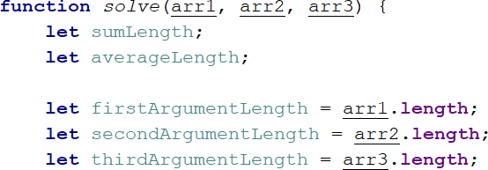

* + Calculate the sum of the three lengths.



* + Calculate the **average length** of the strings **rounded down** to the nearest integer. Use the **Math.floor()**

function.



* + Print the results on the console.



# Largest Number

Write a function that takes **three number arguments** as input and finds the **largest** of them. Print the following text on the console: **`The largest number is {number}.`**.

The **input** comes as **three number arguments** passed to your function. The **output** should be printed to the console.

**Example**

|  |  |
| --- | --- |
| **Input** | **Output** |
| **5, -3, 16** | **The largest number is 16.** |
| **-3, -5, -22.5** | **The largest number is -3.** |

**Hints**

* + Write a function that receives three number arguments.
  + Declare a variable named **result** that will keep the result.

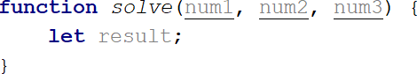

* + Make several checks to find out the largest of the three numbers. Start with num1.

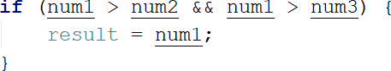

* + Do the same for the others.

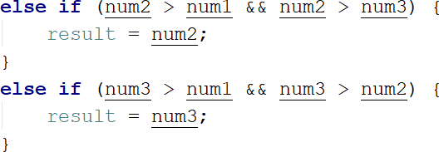

* + Print the result on the console.



# Circle Area

Write a function that takes **a single argument** as an input. **Check the type** of input argument. If it is a **number**, assume it is the radius of a circle and **calculate the circle area**. Print the **area rounded** to **two decimal places**.

If the argument type is **NOT** a number, print the following text on the console:

**`We can not calculate the circle area, because we receive a {type of argument}.`**

The **input** comes as a **single argument** passed to your function. The **output** should be printed on the console.

**Example**

|  |  |
| --- | --- |
| **Input** | **Output** |
| **5** | **78.54** |
| **'name'** | **We can not calculate the circle area, because we receive a string.** |

**Hints**

* Write a function that receives a single argument.
* Declare a variable named **result** that will keep your result.

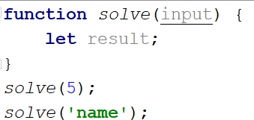

* Check the type of the input argument with the **typeof** operator.



* If the type is equal to **'number'**, calculate the circle area and print it on the console rounded to two decimal places. To do this, use the method **toFixed().**

The **Math.pow()** function returns the base to the exponent power, that is, base exponent. You can find more information about the area [here:](https://en.wikipedia.org/wiki/Circle)

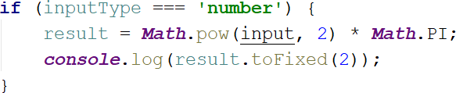

* If the type is **NOT** a **'number'**, print the following text on the console:

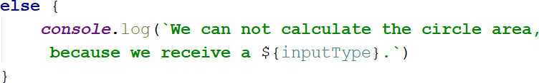

# Math Operations

Write a JS function that takes **two numbers** and **a string** as an input. The string may be one of the following: '**+**', '**-**', '**\***', '**/**', '**%**', '**\*\***'.

Print on the console the result of the mathematical **operation** between **both numbers** and the **operator** you receive as a string.

The **input** comes as **two numbers** and **a string argument** passed to your function. The **output** should be printed on the console.

**Examples**

|  |  |
| --- | --- |
| **Input** | **Output** |
| **5, 6, '+'** | **11** |
| **3, 5.5, '*'** | **16.5** |

**Hints**

* + Write a function which receives **three** arguments:

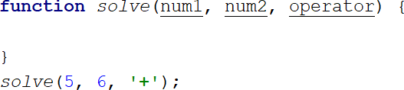

* + Declare a variable named **result** that will keep your mathematical result.
  + Write down the **switch** command that will take the string from your input and depending on it, perform the mathematical logic between the two numbers.

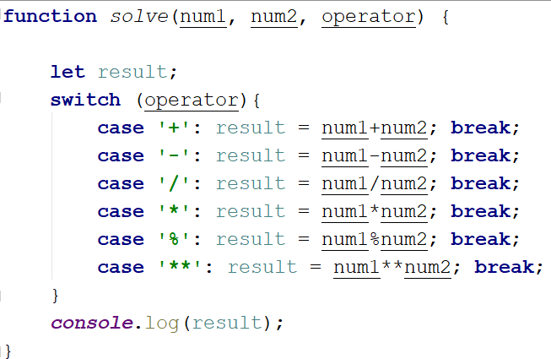

* + Print the result on the console.



# Sum of Numbers N…M

Write a JS function that takes two numbers **n** and **m** as an input and **prints the sum** of all numbers from **n** to **m**. The **input** comes as **two string elements** that need to be **parsed** as numbers.

The **output** should **return** the **sum**.

**Examples**

|  |  |
| --- | --- |
| **Input** | **Output** |
| **'1', '5'** | **15** |
| **'-8', '20'** | **174** |

**Hints**

* + Write a function that receives two string arguments and parse them as numbers. Use **Number(string)**

function to parse the input.

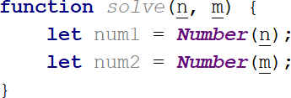

* + Declare a variable named **result** that will keep the mathematical results.
  + Write a **for** loop from **num1** to **num2** and every turn of the cycle, until it’s completed, add the current value.

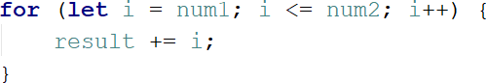

* + Finally, return the result.



# Day of Week

Write a function that prints a number between 1 and 7 when a **day of the week** is passed to it as a string and an

**error message** if the string is **not recognized**. The **input** comes as a single-string argument. The **output** should be returned as a result.

**Examples**

|  |  |
| --- | --- |
| **Input** | **Output** |
| **'Monday'** | **1** |
| **'Friday'** | **5** |
| **'Invalid'** | **error** |

# Days in a month

Write a JavaScript function to get the number of days in a month.

The input comes as two numeric parameters. The first element is the month, the second is the year. The output must return the number of days in a month for a given year.

**Examples**

|  |  |
| --- | --- |
| **Input** | **Output** |
| **1, 2012** | **31** |
| **2, 2021** | **28** |

**Hints**

* + Use **Date()**

# Square of Stars

Write a function that **prints a rectangle** made of **stars** with variable **size**, depending on an input parameter. If there is **no parameter** specified, the rectangle should **always** be of **size 5**. Look at the examples to get an idea.

The **input** comes as a single **number** argument.

The **output** is a series of lines printed on the console, forming a rectangle of variable size.

**Examples**

|  |  |  |  |  |  |  |  |  |  |  |
| --- | --- | --- | --- | --- | --- | --- | --- | --- | --- | --- |
| **Input** | **Output** |  | **Input** | **Output** |  | **Input** | **Output** |  | **Input** | **Output** |
| **1** | **\*** | **2** | **\* \***  **\* \*** | **5** | **\* * * * \***  **\* * * * \***  **\* * * * \*** | **7** | **\* * * * * * \***  **\* * * * * * \***  **\* * * * * * \*** |

|  |  |  |  |  |  |  |  |  |  |  |
| --- | --- | --- | --- | --- | --- | --- | --- | --- | --- | --- |
|  |  |  |  |  |  |  | **\* * * * \***  **\* * * * \*** |  |  | **\* * * * * * \***  **\* * * * * * \***  **\* * * * * * \***  **\* * * * * * \*** |

# Aggregate Elements

Write a program that performs different operations on an array of elements. Implement the following operations:

* **Sum(ai)** - calculates the sum of all elements from the input array
* **Sum(1/ai)** - calculates the sum of the inverse values (1/ai) of all elements from the array
* **Concat(ai)** - concatenates the string representations of all elements from the array The **input** comes as an array of number elements.

The **output** should be printed on the console on a new line for each of the operations.

**Examples**

|  |  |  |  |  |
| --- | --- | --- | --- | --- |
| **Input** | **Output** |  | **Input** | **Output** |
| **[1, 2, 3]** | **6**  **1.8333333333333333**  **123** | **[2, 4, 8, 16]** | **30**  **0.9375**  **24816** |